**Mobile Development**

**Android Project : Loup-Garou Companion App’**



**Goal**

This app’ aims to help a Game Master organise a party of “Loup-Garou” (a well-known board-game). The goal is to assist him, not to do 100% of the work, so that the Game Master still has freedom to do as he wants.

**Architecture of the Application**

The Application consist of various things: 5 Activities, 6 Fragments, some Dialogs and a lot of Classes/Enumerations modelling a game, such as Player, Role, Party…

The Activities are arranged in the following manner :

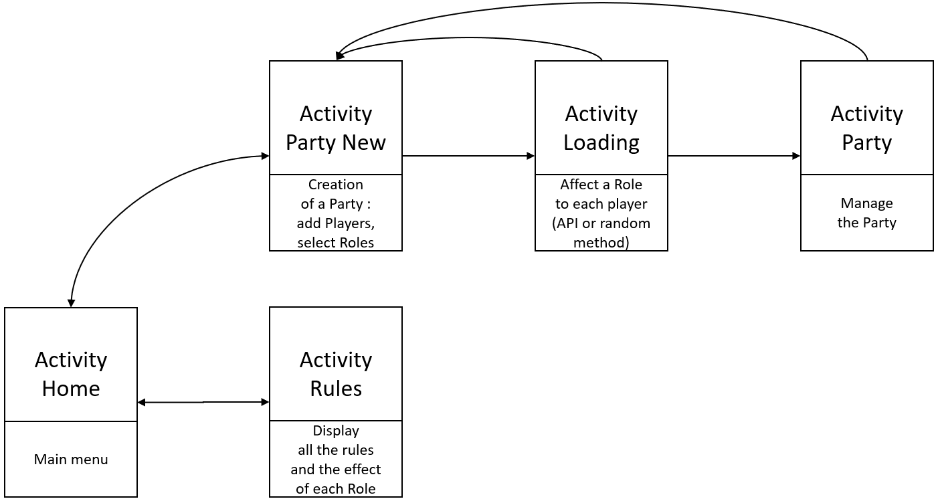

The Fragments are arranged in the following manner :

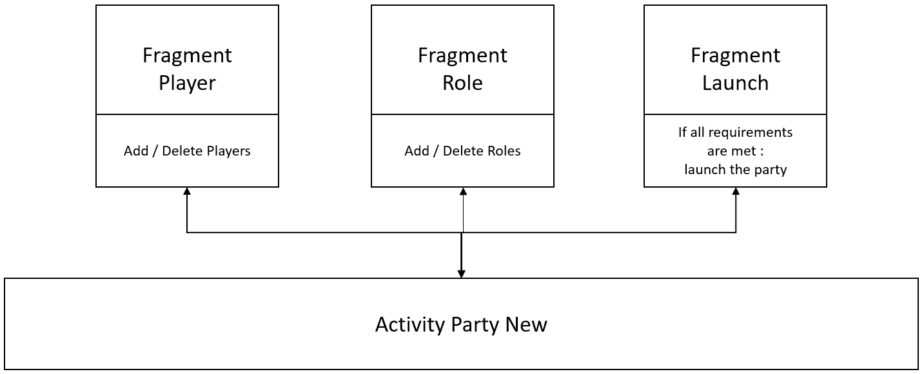

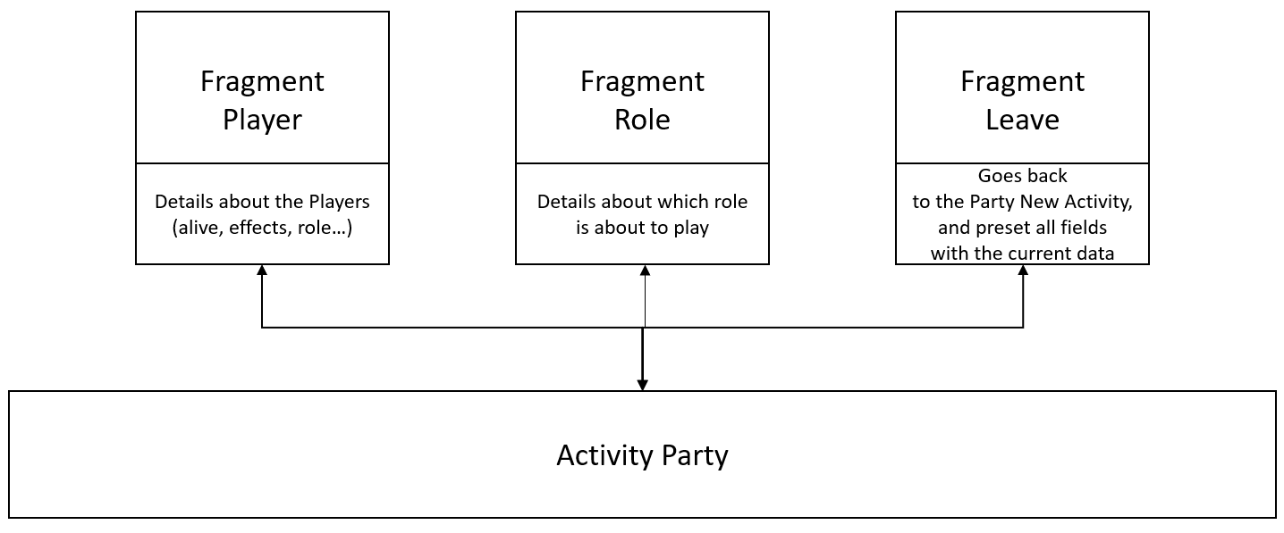

**API**

I use the **Deck of Cards API** : [*https://www.deckofcardsapi.com/*](https://www.deckofcardsapi.com/). Its primary goal is to create Decks (default as well as custom deck), Hands, to shuffle them, to draw cards…But I use it in a different manner.

Let's say you create a party with X players. At this point in the App', you'd have entered X players and selected X roles, but you won't assign them manually ; it is the API which will randomly assign a Role to each Player.

I use it in 3 steps :

* I draw X cards from a newly generated deck ; in my code, I assign each card with a Role
* I create a specific deck with these X cards. Foreach player, I draw one card from the deck, and assign the role corresponding role to the Player.

It may not be optimised, but it allows me to code a rather successful method to randomly assign Roles to each P layer.

**Language**

Since EVERYTHING was entered using the xml resource files, I was able to make a pluri-linguistic version for the app’ : French and English. You can change the tongue in the Home Activity (the very first thing you’ll see when entering the app’).

BUT : everything works perfectly fine as long as you use an emulator, but if you use an actual mobile phone, when you’ll try to change the tongue, the device will reset it to the default language of your phone.